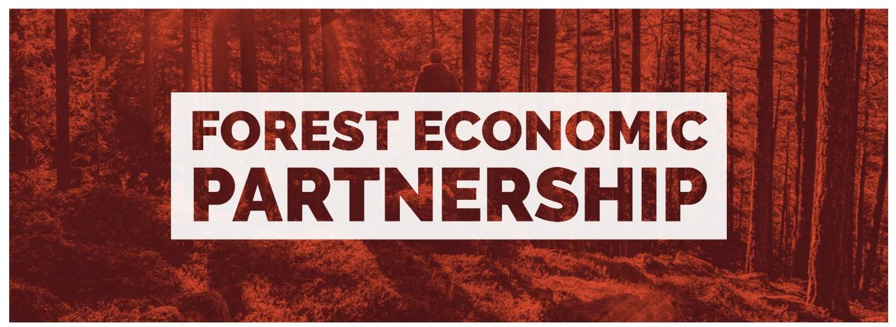
Forest Economic Partnership September Stakeholder Agenda
Wednesday 13th September 2023
17:00-18:30
The Speech House Hotel, GL16 7EL
- Arrival, refreshments & networking 17:00 - 17:15
- Welcome, introduction, and news - (Ian Mean)
- New stakeholders - Welcome Nick Shrager and Deborah Flint, Q+A (Ian Mean)
- BAM – Five Acres Sub-Contract Opportunities (Matthew Williams and Jason Lamb)
- New Rural Business Grants - Rural England Prosperity Fund introduction plus Q&A with grant administrators ALP Synergy, (Anthony Parsons and Louise John)
- FEP Board Governance & finances - (Wendy Jackson)
- Education and Skills sub group update - (Clare Vertigen)
- Digital Connectivity sub group update - (Angela Presdee and Wendy Jackson)
- Meeting close at 18:30

